Website format

Reference : capturebugs.in

First Page :
Left top logo
Right top : Home , services,
Back side transparent Photos slides automatically
Reduce the Font size of the hero session -->Turning Moments Into Timeless Memories
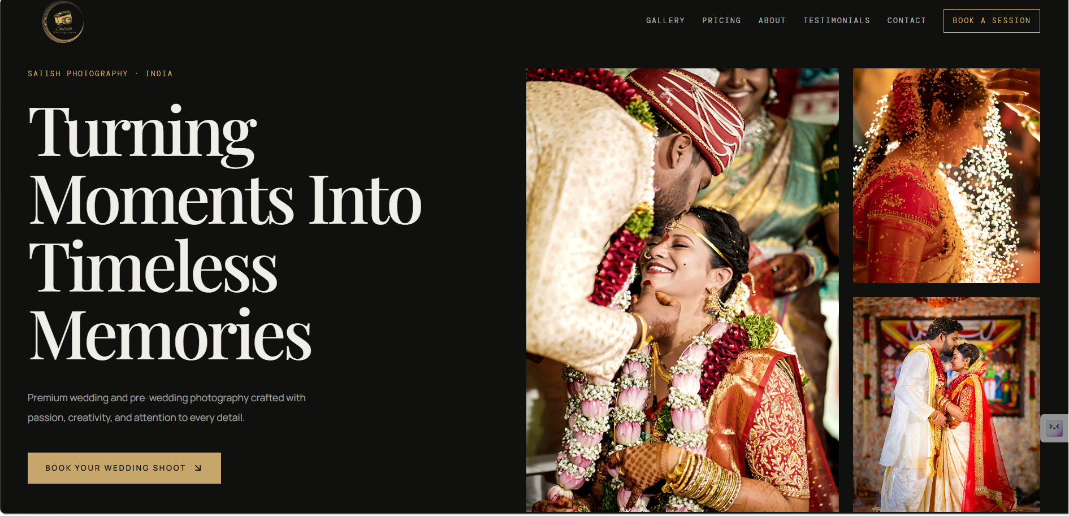

Phone ---whatsapp ---instagram - logos has to be visible every time on every screen

Keep session
WHY COUPLES CHOOSE US ?
Every wedding is a once-in-a-lifetime celebration, and we believe every emotion deserves to be captured with care. From the joyful smiles to the heartfelt moments, we create timeless photographs that tell your unique love story with creativity, passion, and attention to every detail.
Button: Explore Our Work ---> Gallery (Need a Gallery of all latest images )
⭐⭐⭐⭐⭐ (star rating )
Trusted by Happy Couples

Service Section (below the hero page one by one --not side by side-- shuffle postions) 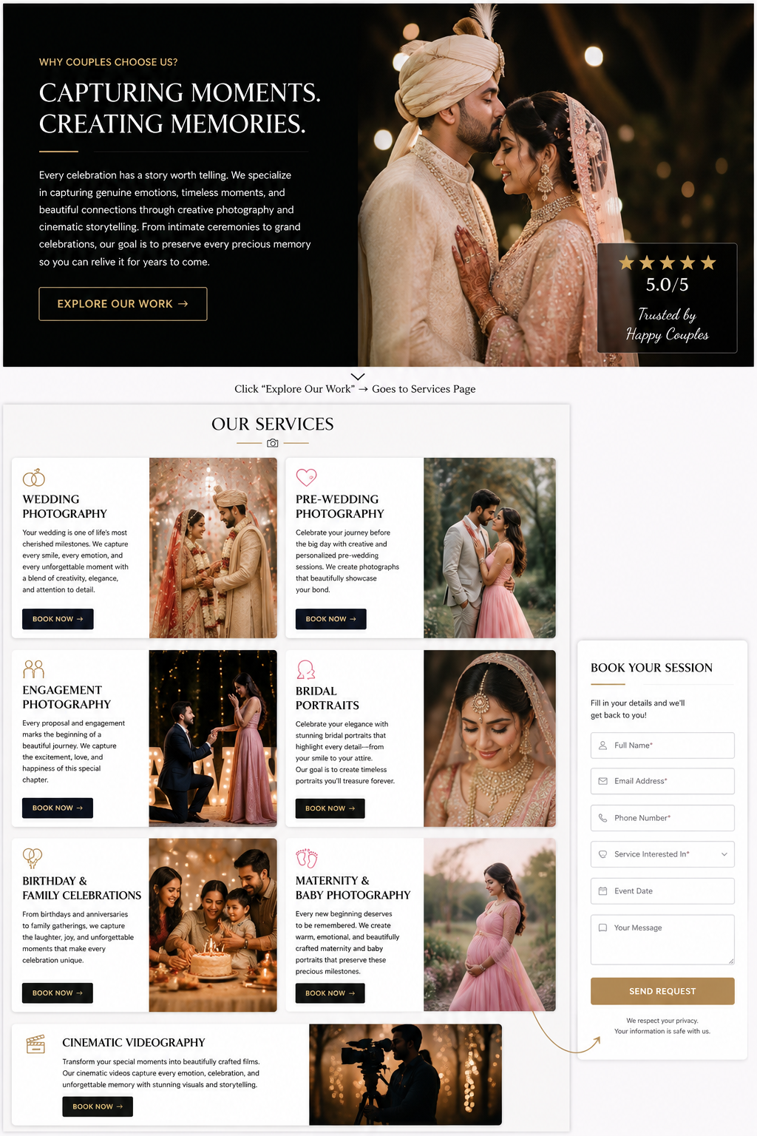 instead of the below section keep services section and give the another button(Book ) along with (explore )
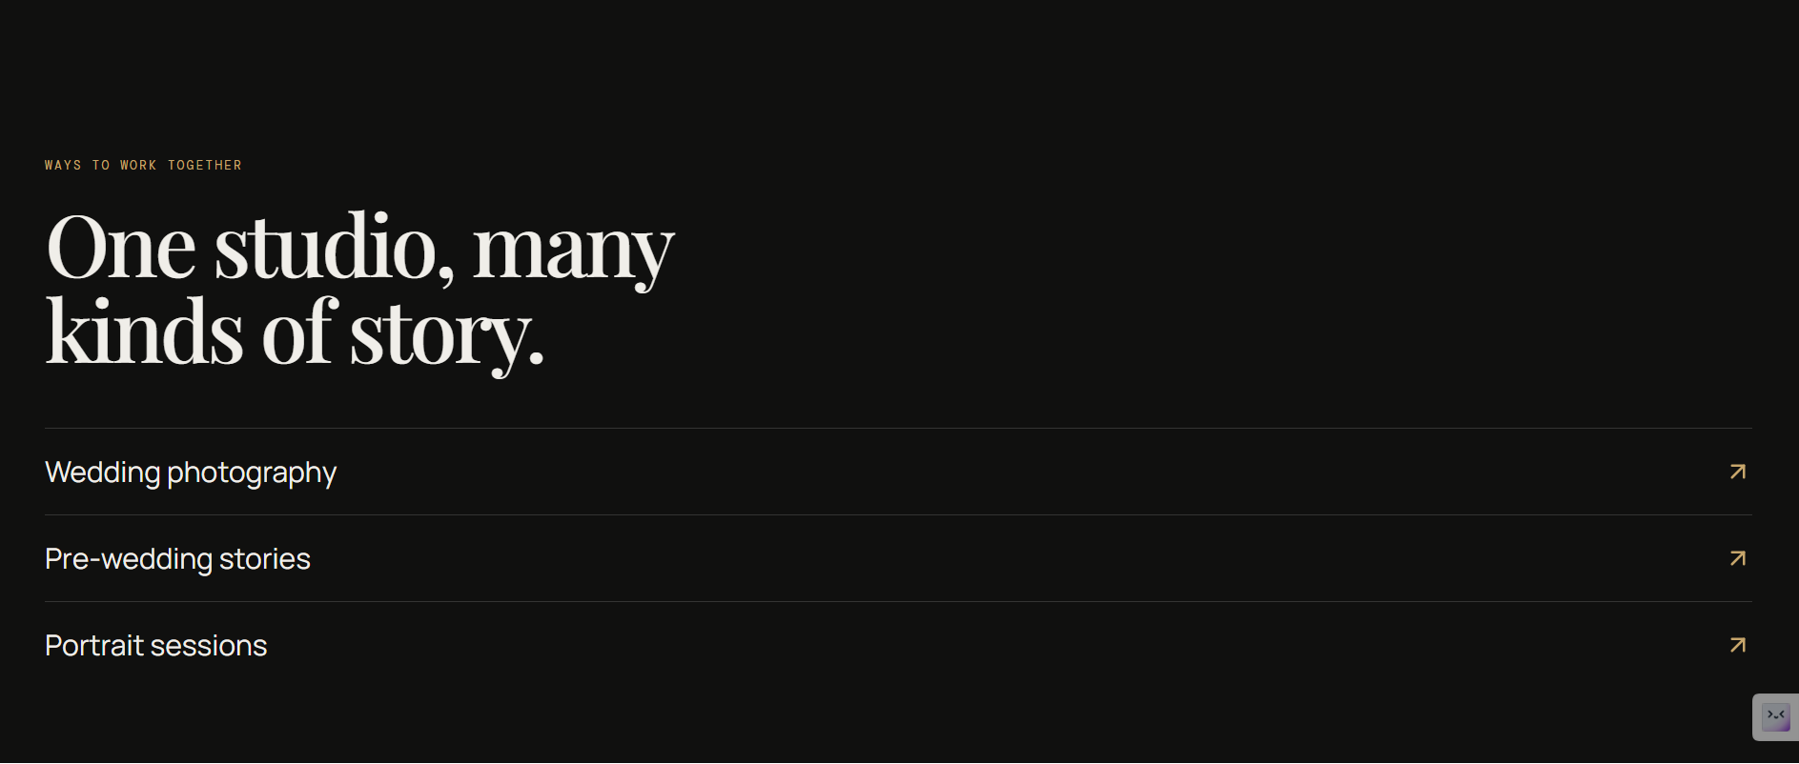
This section when click explore /view / button Go to the services page (inn the services page same keep the service name and add few image and keep book now button , when this button click some form as to come to fill )
CAPTURING MOMENTS. CREATING MEMORIES.
Every celebration has a story worth telling. We specialize in capturing genuine emotions, timeless moments, and beautiful connections through creative photography and cinematic storytelling. From intimate ceremonies to grand celebrations, our goal is to preserve every precious memory so you can relive it for years to come.
💍 Wedding Photography
Your wedding is one of life's most cherished milestones. We capture every smile, every emotion, and every unforgettable moment with a blend of creativity, elegance, and attention to detail, ensuring your memories remain timeless.
Button: Explore Wedding Stories →

❤️ Pre-Wedding Photography
Celebrate your journey before the big day with creative and personalized pre-wedding sessions. Whether it's a romantic outdoor location or a meaningful place that reflects your story, we create photographs that beautifully showcase your bond.
Button: View Pre-Wedding Gallery →

💑 Engagement Photography
Every proposal and engagement marks the beginning of a beautiful journey. We capture the excitement, love, and happiness of this special chapter with natural, heartfelt, and artistic photography.
Button: Discover Engagement Shoots →

👰 Bridal Portraits
Celebrate your elegance with stunning bridal portraits that highlight every detail—from your smile to your attire. Our goal is to create timeless portraits that you'll treasure forever.
Button: View Bridal Gallery →

🎉 Birthday & Family Celebrations
From birthdays and anniversaries to family gatherings, we capture the laughter, joy, and unforgettable moments that make every celebration unique.
Button: Explore Celebrations →

👶 Maternity & Baby Photography
Every new beginning deserves to be remembered. We create warm, emotional, and beautifully crafted maternity and baby portraits that preserve these precious milestones for generations.
Button: View Baby & Maternity Gallery →

🎥 Cinematic Videography
Transform your special moments into beautifully crafted films. Our cinematic videos capture every emotion, celebration, and unforgettable memory with stunning visuals and storytelling.
Button: Watch Our Films →


- Remove Quality Creative on time -- where ever you see s
- date ki event data ani peeti dd-mm-yyyy format pettu , Type of session drop down lo "others" add cheyi -- Keep any any transaparent on back side -- reduce font size -- make it something good feeling empty while seeing
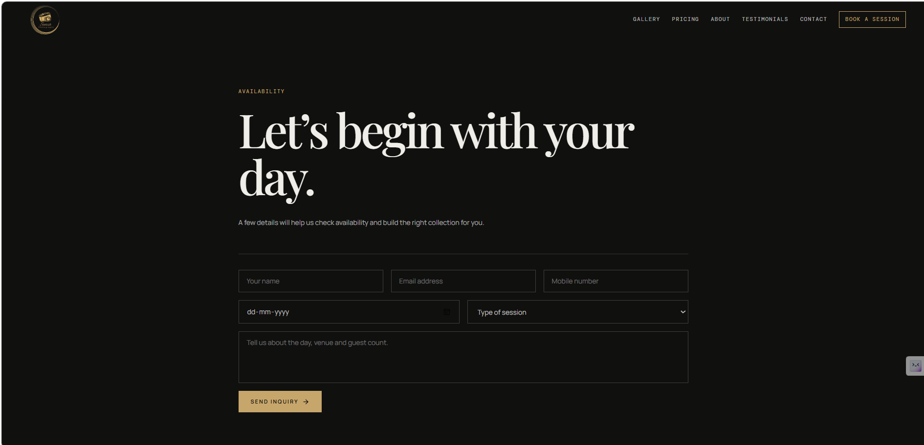
- Change image position -- make it portrait size frame -- make section beatiful remove the padding and spaces -- Link “About” to this section -- keep this at the end and above the footer
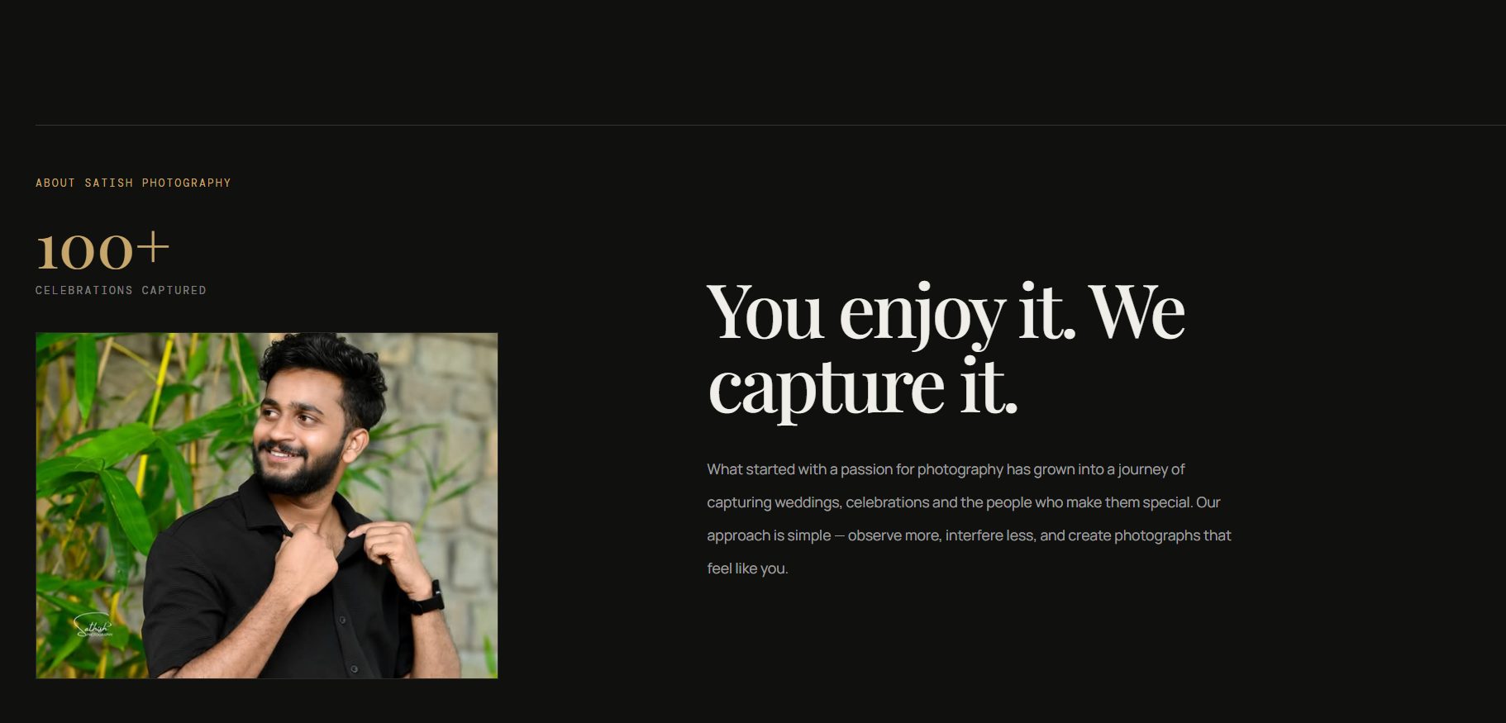

- Testimonals and this -- Change the Font size and format -- change the session format in the background any image add --transaparent image
- 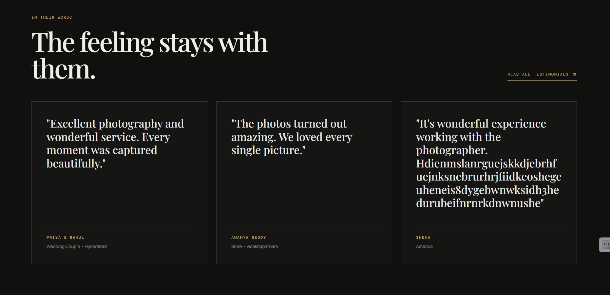
Need like this but differently -- above the About us and footage -- you kept button check avaiability like that but instead of navigation , I need the section on the Home page only
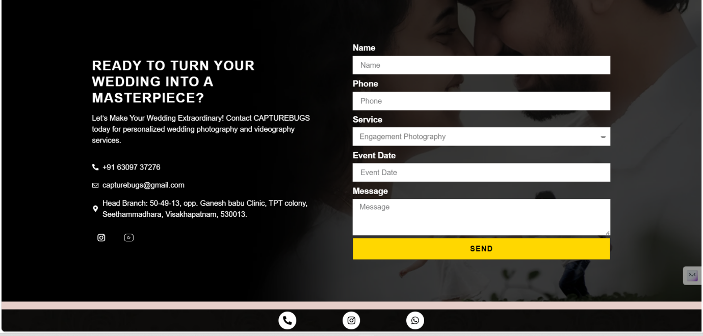
6) I need like this but something different and uniqe way showcasing images
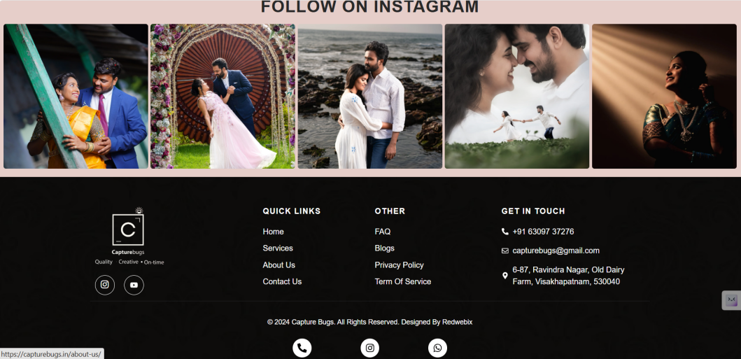

7 ) Gallery section : reduce the image size more images has to be fit - some picture may be landscape some may be portraits
The archive

Every frame has a pulse.
Explore stories arranged by the feeling they hold — from first light to the last song.
Chanmge to
OUR STORIES
The moments we loved capturing.
From big celebrations to the little moments in between, explore our latest work.

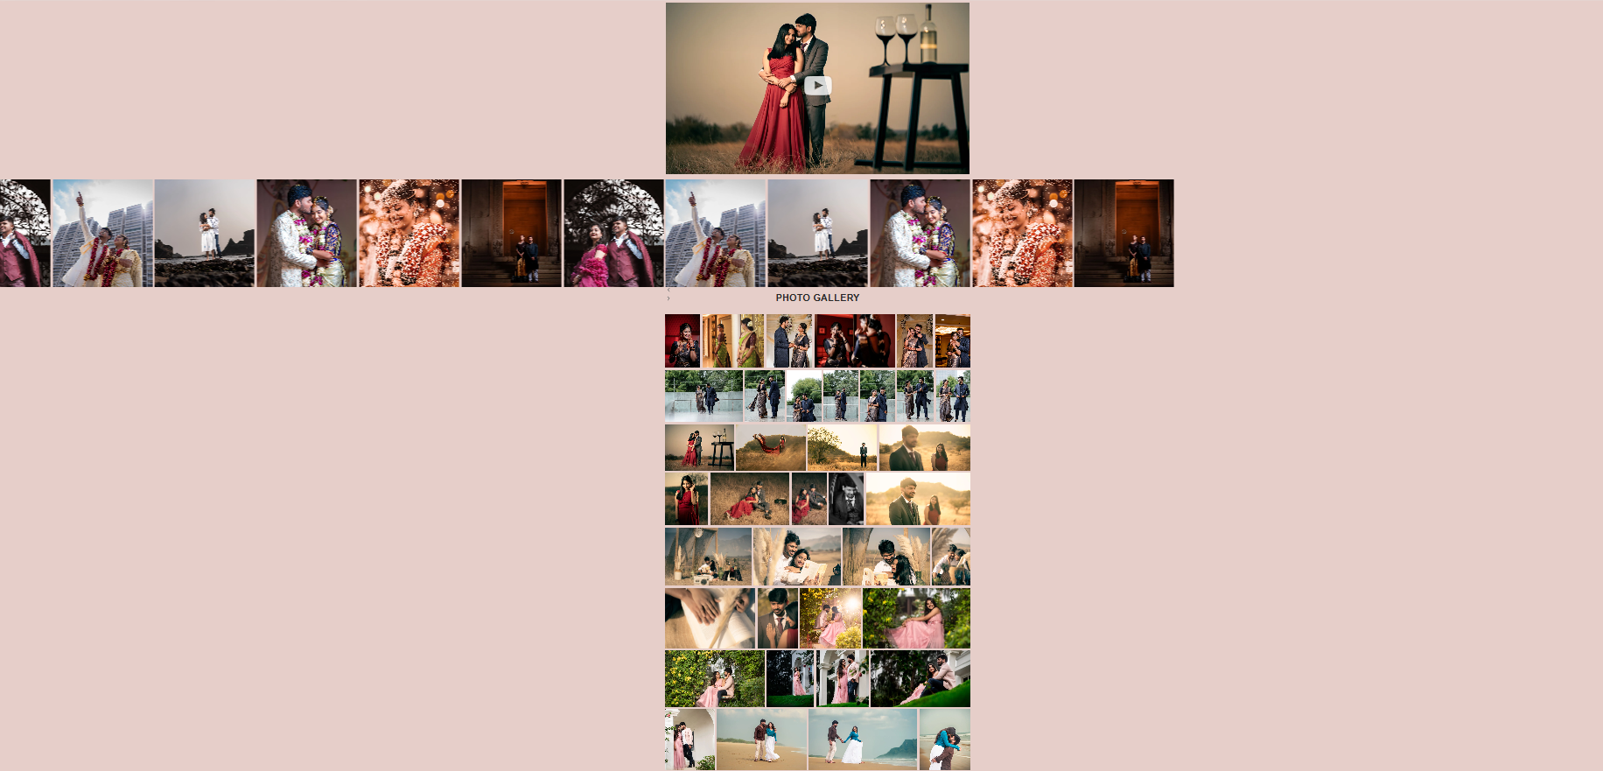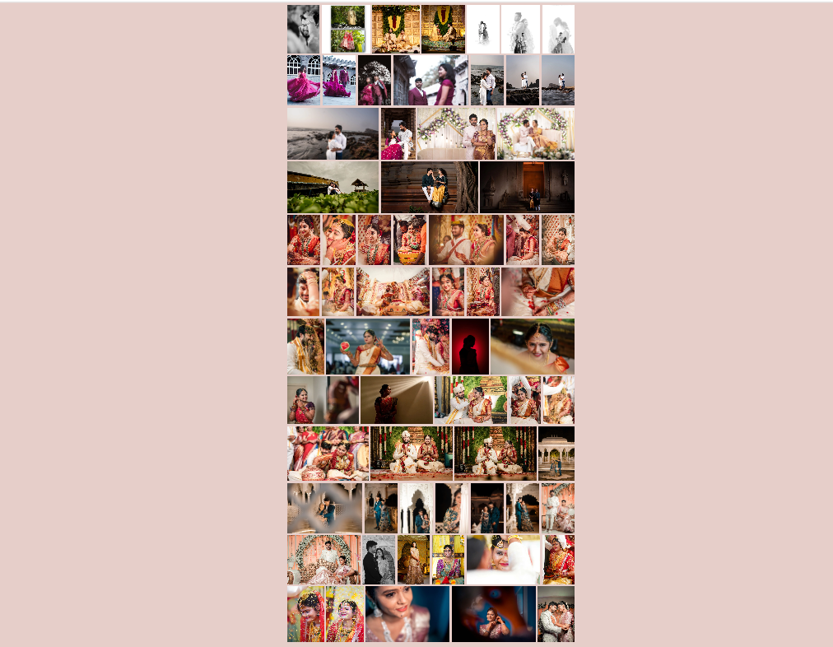

Contact section : REduce font size -- add something looking empty
Replace with below text
Start a conversation

Your story deserves to be beautifully remembered.
Reach out to us about your plans, your ideas, or simply to say hello. We’re always happy to connect.
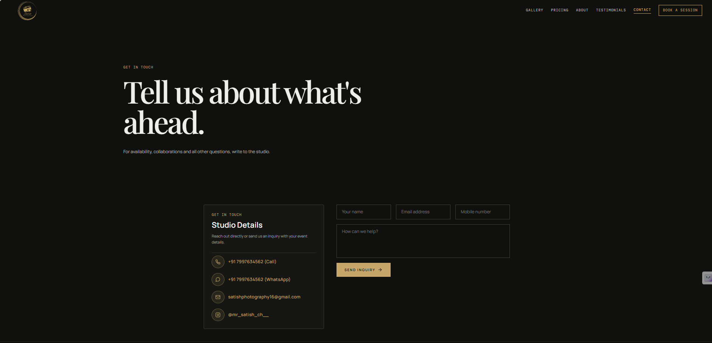

Packages section - I will check with him

